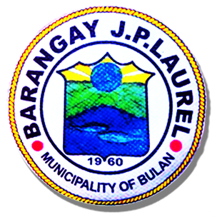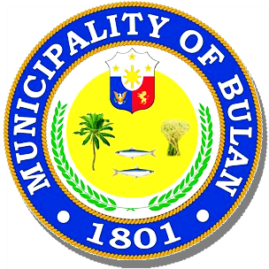Republic of the Philippines

**MUNICIPALITY OF BULAN**

Sorsogon  SORSOGON

**BARANGAY J.P. LAUREL**

OFFICE OF THE PUNONG BARANGAY

**BARANGAY CERTIFICATE**

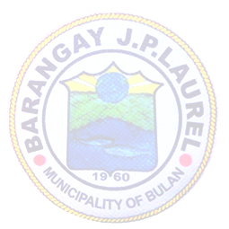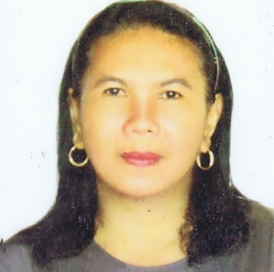

**BARANGAY OFFICIALS**

**NORIE G. CAÑEZAL**

**Punong Barangay**

**BARANGAY KAGAWAD**

**MARY JANE G. ESQUILLO**

**JUNIE G. BREZUELA**

**LERMA O. GRANADIL**

**RENAN G. GOLLOSO**

**VENER P. BERANIA**

**FLORENCE M. SUS**

**JOSEPH H. ALMOGUERA**

**SK CHAIRMAN**

**RONNEL G. GUETA**

**EDNA H. BONAGUA**

Barangay Secretary

**AGNES R. JUAB**

Barangay Treasurer

**TO WHOM IT MAY CONCERN:**

**This is to certify that RIA H. ABSALON, of legal age and a resident of Barangay J. P. Laurel,Bulan, Sorsogon, is an indigent of our barangay. His/Her parent/guardians are:**

**ALFREDO F. ABSALON JR. MARIAM H. ABSALON**

**Father(Fisherman) Mother(Housewife)**

**With annual income Php 30,000.00**

**This certification is issued upon request of the interested party this 02th day of MAY, 2022 at the office of the Punong Barangay, Barangay J. P. Laurel, Bulan, Sorsogon, Philippines for whatever intent it may may serve.**

**Approved by:**

**NORIE G. CAÑEZAL**

**Punong Barangay**

Approved:

***NORIE G. CAÑEZAL***

Punong Barangay

Attested:

***EDNA H. BONAGUA***

Barangay Secretary

***Note!:*** *Not valid without seal*

//.om~.19